

**JavaTech Group**



**Payroll Management System for Information Technology Company**

**Use-Case Specification: Delete user**

Version 1.0

**Table of Contents**

1. Ordering Book 3

1.1 Brief Description 3

1.2 Actor 3

2. Flow of Events 3

2.1 Basic Flow 3

3. Special Requirements 4

4. Preconditions 4

5. Postconditions 4

6. Extension Points 4

**Use-Case Specification: Delete user**

# Ordering Computer

## Brief Description

This use case defines the step of Delete user. Admin can easily delete an employee information from the system by clicking the delete user button.

## Actor

Admin.

# Flow of Events

## Basic Flow

From the manage employee view, the admin search for the employee id. The admin then click to delete user button, the system will show a prompt to the admin to ensure that they want to delete this user. The admin click delete button to delete user.

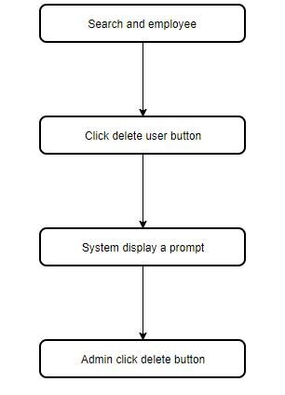

***Basic flow of Delete user***

# Special Requirements

No special requirements.

# Preconditions

There are users in the system’s database.

# Postconditions

No postcondition.

# Extension Points

No Extension point.